**Analysis of Laser Powder Bed Fusion using COMSOL**

Tushar Vishwanath (1227565302)

MAE 545 : Modern Manufacturing Methods

***Introduction to Laser Powder Bed Fusion***

Laser Powder Bed Fusion (LPBF), also known as Selective Laser Sintering (SLS) or Selective Laser Melting (SLM), is a type of additive manufacturing, commonly referred to as 3D printing. It utilizes a high-powered laser to selectively melt and fuse metal powder particles to create three-dimensional objects. This process involves a laser beam that scans a bed of metal powder, melting and fusing the powder particles to form the desired shape of the object being printed.

Furthermore, LPBF is not limited to metals; it can also accommodate various non-metallic materials such as ceramics, polymers, and composite powders. For example, in the case of polymers, the process is often referred to as Selective Laser Sintering (SLS) or Powder Bed Fusion (PBF), where a high-powered laser selectively sinters or fuses powdered polymer materials together, layer by layer, to build up a three-dimensional object. Similarly, in the case of ceramics, the process may involve Selective Laser Sintering (SLS) or Selective Laser Melting (SLM) of ceramic powders to produce components with specific properties and geometries.

As the printing progresses, a new layer of powder is spread over the previously printed layer, and the laser beam melts and fuses the new layer to the previous one. This layer-by-layer process continues until the final object is complete.

LPBF, regardless of the material being used, is capable of producing highly complex and intricate parts with exceptional mechanical properties, such as high strength, hardness, and corrosion resistance. This makes it an ideal manufacturing process for a wide range of industries, including aerospace, automotive, biomedical, and defense. The technology has also shown great potential for producing customized parts with unique geometries and features that are difficult or impossible to achieve using traditional manufacturing methods.

***Motivation for COMSOL Analysis***

COMSOL offers a comprehensive simulation platform for analyzing and refining the Laser Powder Bed Fusion (LPBF) technique, also known as laser powder bed fusion melting. LPBF is an advanced 3D printing method involving the precise melting and fusion of metal powder particles with a high-intensity laser to fabricate complex three-dimensional objects. Through COMSOL's array of simulation modules, such as COMSOL Multiphysics, we can fine-tune LPBF process variables like laser power, scanning velocity, and powder bed temperature to enhance component quality while minimizing production expenses. Moreover, COMSOL enables exploration into the influence of diverse material properties and powder characteristics on final part integrity, as well as the detection and mitigation of potential defects through process optimization or subsequent treatment methods.

While ANSYS also offers simulation capabilities for LPBF processes, opting for COMSOL would provide us with a fresh learning experience as per the guidelines of the subject.

***Breakdown of the project (Methodology) :***

1. Material Selection : Some of the most commonly used metals used for laser bed powder fusion were used for the COMSOL analysis. My main focus centered on aluminum and copper. However, I explored other materials such as stainless steel, cast iron, AlSi10Mg, etc: to get better understanding of the process.
2. CAD File for Analysis : I built the geometry by using the block command in the inbuilt geometric modeler or COMSOL. The dimensions I defined are L = 10mm, W = 5mm, and H = 2.5mm for the analysis. I also prepared a model in SolidWorks(iges and stp), but did not import it as we are using a shared COMSOL platform.

Parameters entered for model building and analysis is shown in the picture below,

For a comparison analysis I have used a similar input as provided by the TA

1. COMSOL Analysis :
2. Meshing : The materials were analyzed for almost same parameters to check how the intensity, speed of laser affect the additive manufacturing process. I utilized a fine predefined mesh for the analysis, bolstered by additional support from breaking it with free tetrahedra. Furthermore, I refined the edges four times, focusing on edges 4 and 5 (the laser path), to enhance solution data accuracy. Adaptive sizing produced a mesh dimension with a maximum element size of 8E-4, a minimum element size of 1E-4, a maximum element growth rate of 1.45, a curvature factor of 0.5, and a narrow region resolution of 0.6.

Fig showing model of powder bed onto which the laser beam is being hit.

1. Steady state thermal analysis : Engineers and designers have a good grasp of how temperatures are spread within a system or a component when it's running steadily. This involves crunching heat transfer equations, taking into account the materials' thermal traits, the conditions at the boundaries, and any sources or drains of heat. Using COMSOL, I delve into this temperature puzzle. COMSOL helps me figure out not just the temperature distribution inside the system but also any thermal stresses or deformations that come with it with the help of input equations. This kind of insight is key to tweaking the design, making sure it runs smoothly and safely as intended.  
     
   The initial temperature was set as 293.15K (Text) and convective heat flux was added into the system that was defined as 50 W/𝑚2K by selecting the acting face of the figure, and the geometry, path and start point are defined.
2. Initial temperature : The initial temperature is defined as 293.15K (external) and maintained uniformly throughout its volume.
3. Moving heat energy : The velocity of the laser beam is adjusted to 50 millimeters per minute, determining its rate of movement across the workpiece surface. With a beam radius of 50 micrometers, the simulation begins at 0 seconds and concludes at 15 seconds. The workpiece surface is divided into 200 segments to simplify computation while retaining essential details of the laser machining process. Properties such as melting temperature, absorption coefficient, and source power vary based on the material being processed by the laser beam.

Ejection of powder particles and droplet spatters during the

Representation of a laser beam hitting powdered particles. Generated using Adobe illustrator.

*Rapid Prototyping Journal. 28. 12. 10.1108/RPJ-12-2021-0342.*

*Moving laser beam at 1s and 2s interval*

***Results and Discussion :***

b

a

*The figures show the isometric view of the temperature distribution in a) copper and b) aluminum.*

Test results were documented under different power source settings, absorption coefficients, and melting temperatures, with parameters chosen according to the TA's recommendations for analysis. The model was segmented, and isometric views were provided to facilitate comprehension and illustrate the depth of the beam's impact on various materials. Melting temperatures specific to each material were allocated for respective tests. Maximum temperatures of 575K and 494K were observed for aluminum and copper alloys, respectively, over 200 load steps and a duration of 15 seconds.

b

a

Respective probe plots of a) copper and b) aluminum when subjected to laser bed fusion for a duration of 15 seconds.

The temperature distribution that we have obtained does not really reach the melting temperature of the respective materials. This can be avoided by increasing the laser power, decreasing the scanning speed and increasing the laser beam radius. The materials that I have used are also conductive which causes fast distribution of the heat across the surface. Since the goal of the project is to analyze the process and not the material itself, I have not looked that deeply into the process.

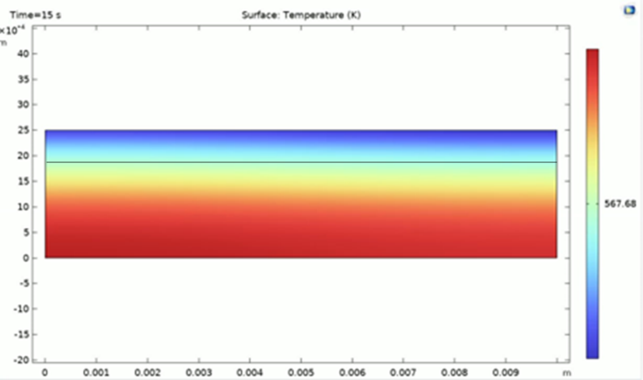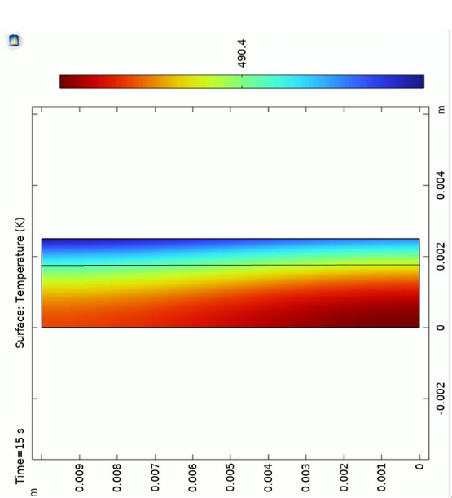

The melting pool depth for aluminum is around 0.002m and copper is around 0.0018m. The depths are similar due to similar properties, but you can see accumulation of thermal energy in aluminum due to the lesser conductivity when compared to copper.

***Conclusion***

COMSOL offers a comprehensive set of tools for simulating the Laser Beam Fusion (LBF) process, encompassing thermal, fluid, and mechanical behavior. These simulations can be instrumental in optimizing process parameters, minimizing iterations needed for desired part quality, and forecasting final part properties.

From the simulation outcomes, several key conclusions emerge. Firstly, the temperature distribution profoundly impacts LBF's success, influencing crucial factors like powder melting, solidification, and grain growth. Ansys simulations reliably forecast temperature distributions during the LBF process, facilitating parameter optimization for attaining desired part quality.

The analysis revealed significant differences in the thermal behavior between the two materials.

1) Copper with high thermal conductivity produced,

1. Faster heating and cooling response.
2. Comparatively reduced peak temperature.
3. Uniform melt pool depth (distribution of temperature).

2) Aluminum with comparatively smaller thermal conductivity produced,   
   
 a) Slower heating and cooling response.  
 b) Larger peak temperature  
 c) Non uniform melt pool depth over time.

***Other analysis (extra)***

Since the equations mentioned for the analysis have been given by the TA, I did some literature review to analyze parts of different morphologies and axes.   
One such method is by changing the equations along the z axis. And using cylindrical morphology. The variable used are,

Where p = radius and defined movement is along the z axis

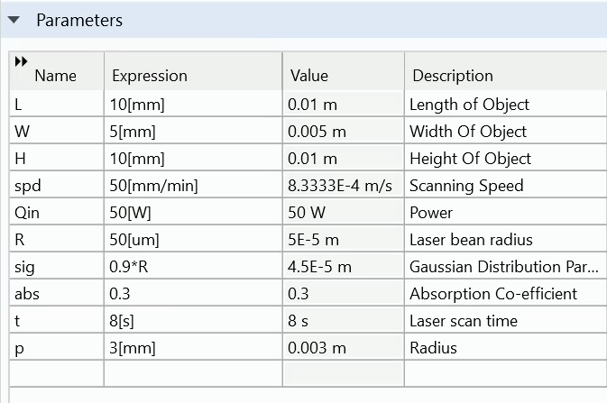

Chao, W et al. [4] mentioned how Laser Powder Bed Fusion can be used on a cylindrical/spherical unit and by tracking the edge parameter through a linear equation or by inputting a PDE in lumerical (Ansys). I just did a basic analysis over a cylindrical domain.

b

a

1. Cylinder mesh(fine) b) Temperature distribution curve over two points at 0s over the cylindrical domain.

***References :***

1. Dev Singh, D. (2020). Powder bed fusion process: A brief review. Materials Today: Proceedings 46 (2021) 350–35. [1]
2. Lindström, V.; Liashenko, O.; Zweiacker, K.; Derevianko, S.; Morozovych, V.; Lyashenko, Y.; Leinenbach, C. Laser Powder Bed Fusion of Metal Coated Copper Powders. Materials 2020, 13, 3493. <https://doi.org/10.3390/ma13163493>. [2]
3. Sohini Chowdhury, N. Yadaiah, Chander Prakash, Seeram Ramakrishna, Saurav Dixit, Lovi Raj Gupta, Dharam Buddhi, Laser powder bed fusion: a state-of-the-art review of the technology, materials, properties & defects, and numerical modelling, Journal of Materials Research and Technology, Volume 20,2022,Pages 2109-2172,ISSN 2238-7854,<https://doi.org/10.1016/j.jmrt.2022.07.121.> [3]
4. Chao, W. (2018). 3D printing of multiple metallic materials via modified selective laser melting (67th ed., pp. 245-248). CIRP Annals - Manufacturing Technology 67 (2018) 245–248. [4]
5. Cobbinah, P.V.; Nzeukou, R.A.; Onawale, O.T.; Matizamhuka, W.R. Laser Powder Bed Fusion of Potential Superalloys: A Review. Metals **2021**, 11, 58. [https://doi.org/10.3390/met11010058.](https://doi.org/10.3390/met11010058.%20) [5]
6. Ullah, Abid & Ur Rehman, Asif & Salamci, Metin & Pıtır, Fatih & Liu, Tingting. (2022). The influence of laser power and scanning speed on the microstructure and surface morphology of Cu2O parts in SLM. Rapid Prototyping Journal. 28. 12. 10.1108/RPJ-12-2021-0342. [6]

**THANK YOU**